**FOR YOUR INFORMATION:**

Dear Parishioners of

**OUR LADY OF THE WAY EMU PLAINS**

Beginning this weekend our Sunday Mass will be available through Youtube and Facebook.

Access through Youtube -

Option 1. by copying the link below into your browser or

Click on the following link:  
<https://youtu.be/gkGO0YSL9LI>

Option 2: Go to Youtube on your TV, Computer or mobile:

In the Youtube search bar enter the following:

**Our Lady of The Way Emu Plains**

Look for the following account picture:

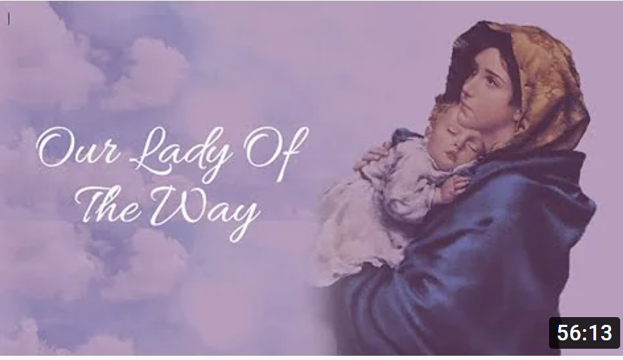

For Facebook go to: OLOWPARISHEMUPLAINS.

Please visit our Parish Website for more information.

**GOD’S BLESSINGS AND PEACE BE UPON US ALL IN THIS TIME OF TRIAL.**

**Fr. Michael and Parish Staff.**